**NAME: SWATHI.M.NAIR**

**ROLLNO: 19EUEC160**

**AASIGNMENT: 2**

Challenge: - Upload the dataset to Cognos Analytics, prepare the data, explore and Create Interactive Dashboard.

Task 1: Sales by Customer.

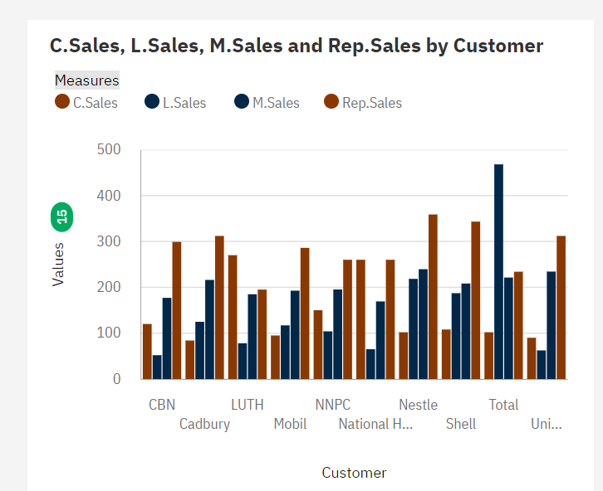

Task 2: Sales by Location.

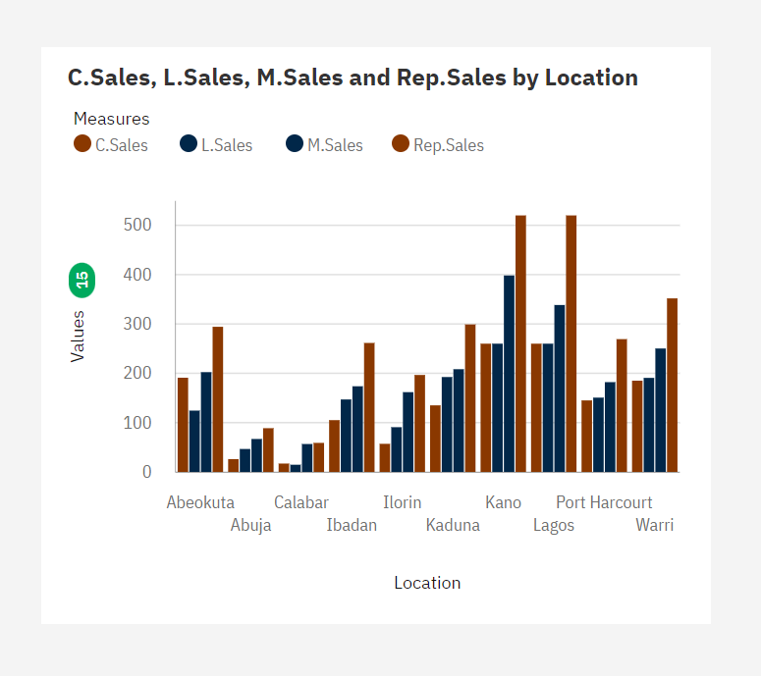

Task 3: Sales by Sales Representative.

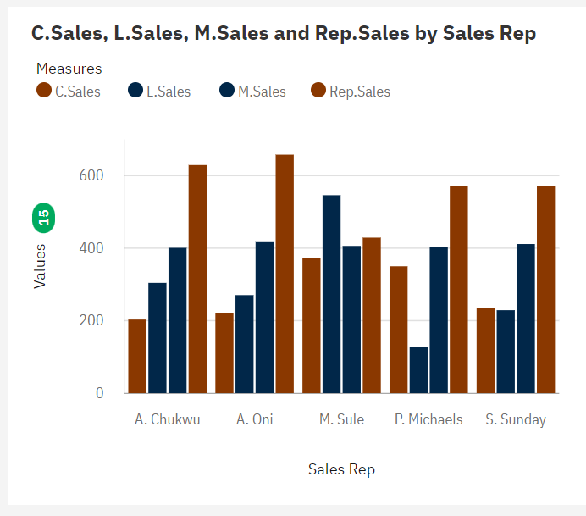

Task 4: Received Inventory from Supplier

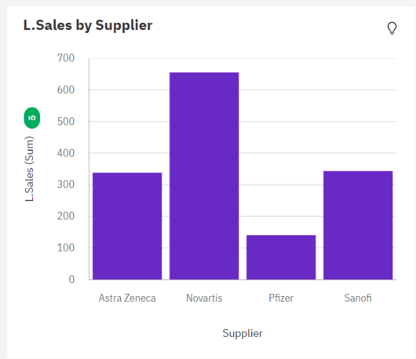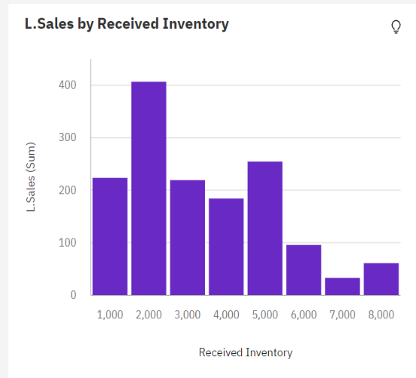

Task 5: Inventory Stock for Warehouse Locations

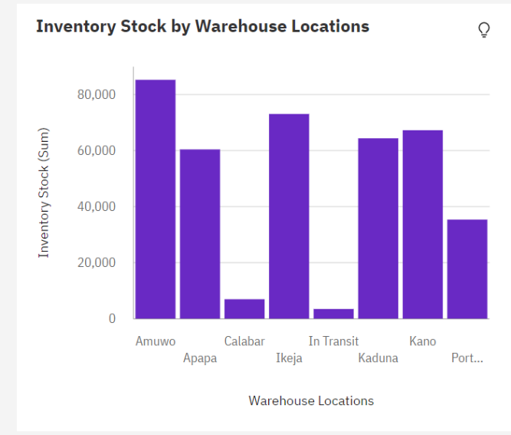

Task 6: Sales Trend

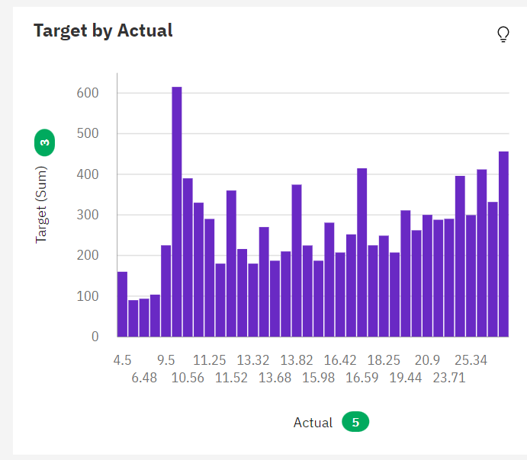

Task 7: Monthly Sales

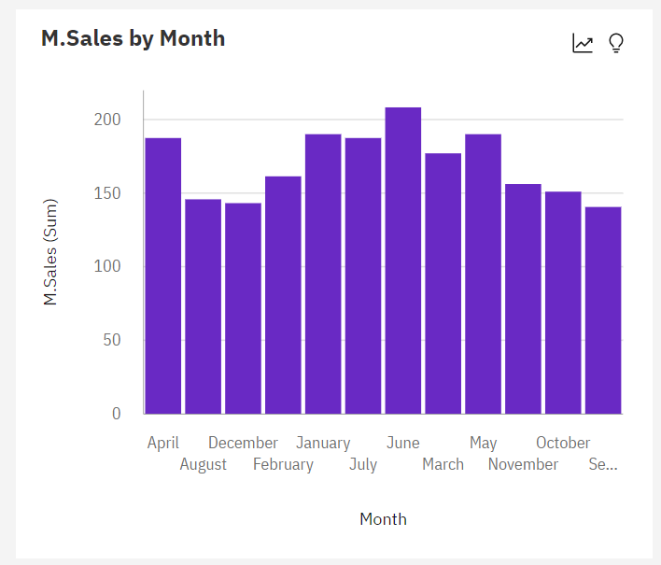

Task 8: Actual and Received Inventory by Month

